Hi Ladies

I am sure you are all well and truly into the routine of the new year so I thought I would send out a newsletter with some of the latest product.

The latest template AZZA has released in Australia is a good one, very easy to use and I think very versatile.

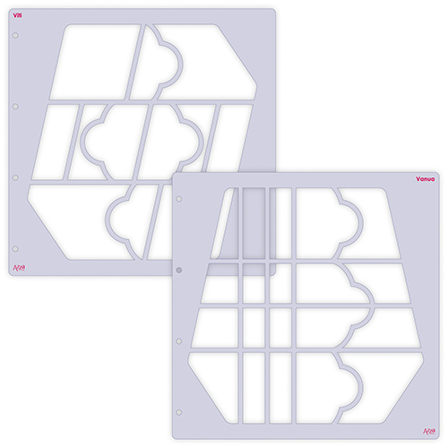

GAB 709 – Fiji Duo Stencil
As with all AZZA templates this template is available on its own ($25.00) or as a Studio Kit ALI 1501 ($50.00).

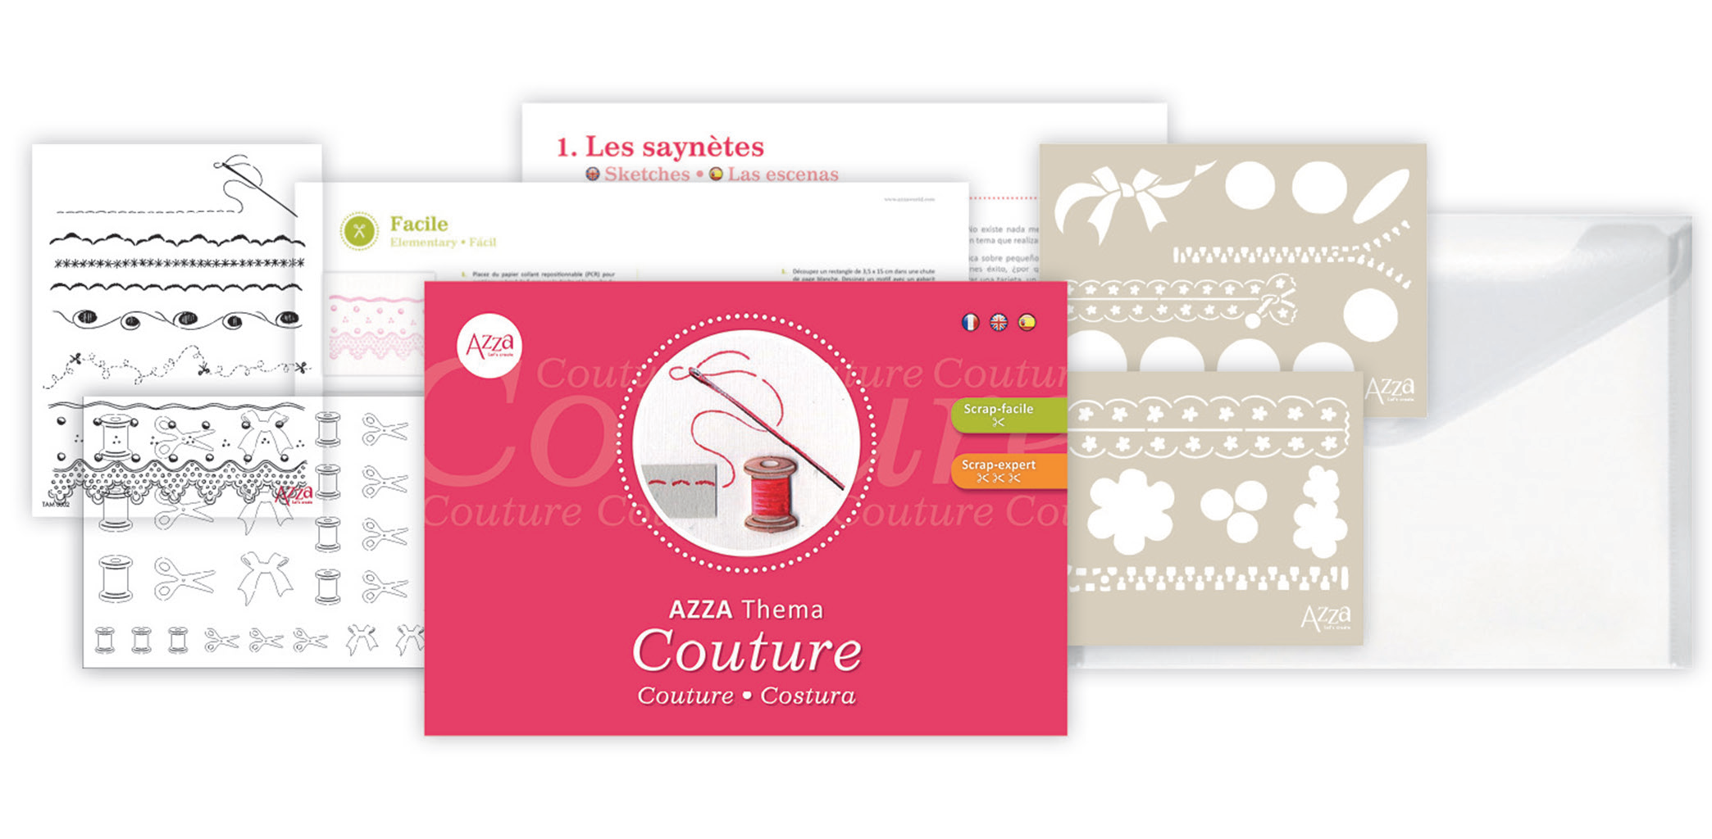
The Theme Kit running alongside this template is ‘Couture” – Kit 3000 - $70.00. The kit consists of the usual booklet, a set of stamps (14x18cm) a Deco Duo stencil and a sheet of Silhouette Figures. Remember all these items can be purchased individually expect the booklet.

The February-March Basket is PAN 023 - $110.00

This basket consists of the Fiji Studio Kit and the Couture Theme Kit.

Herewith a few sample pages:

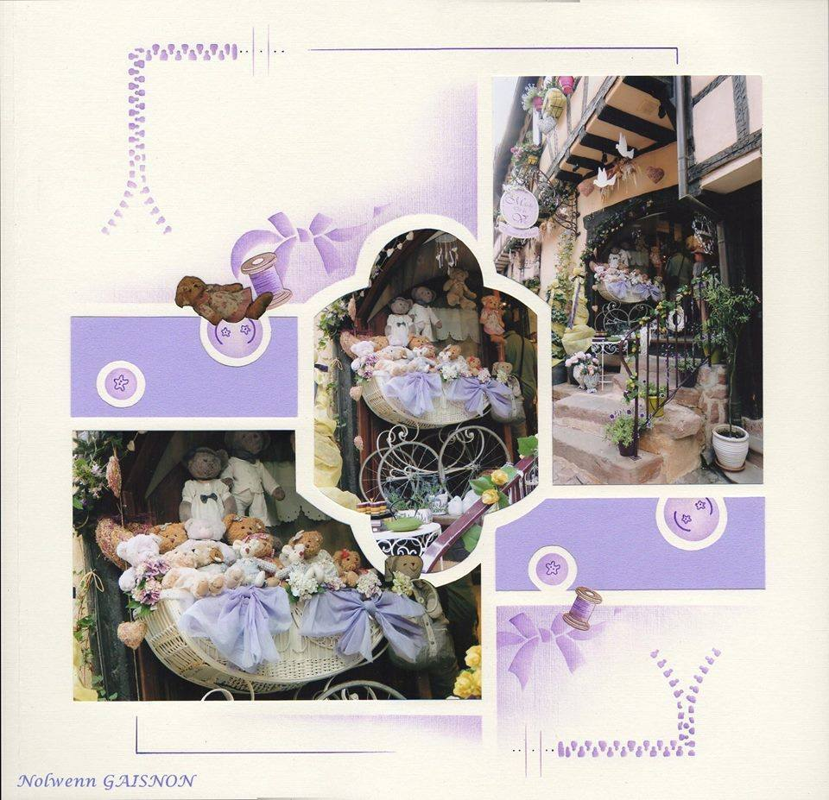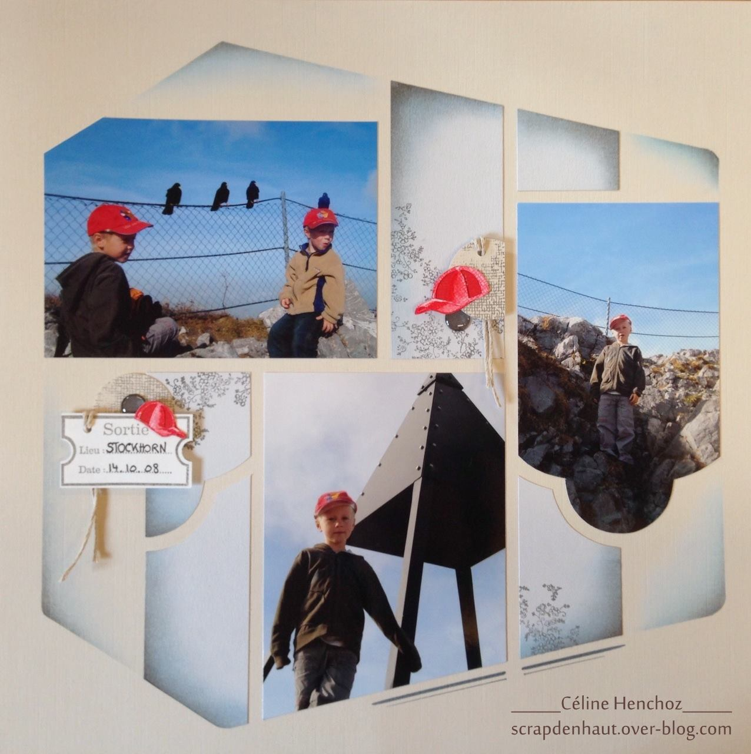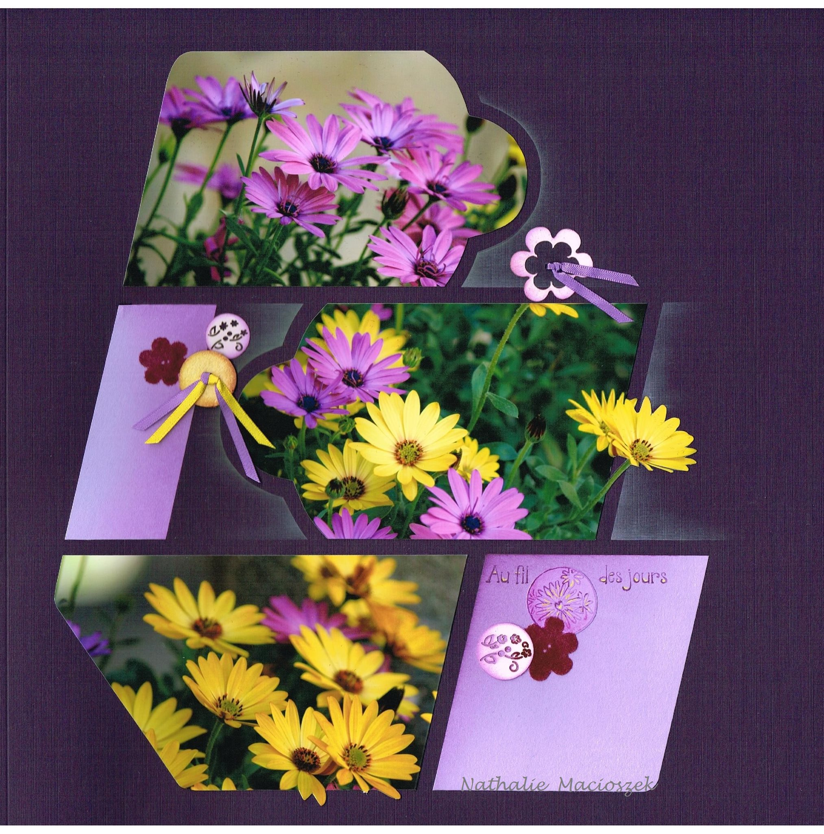

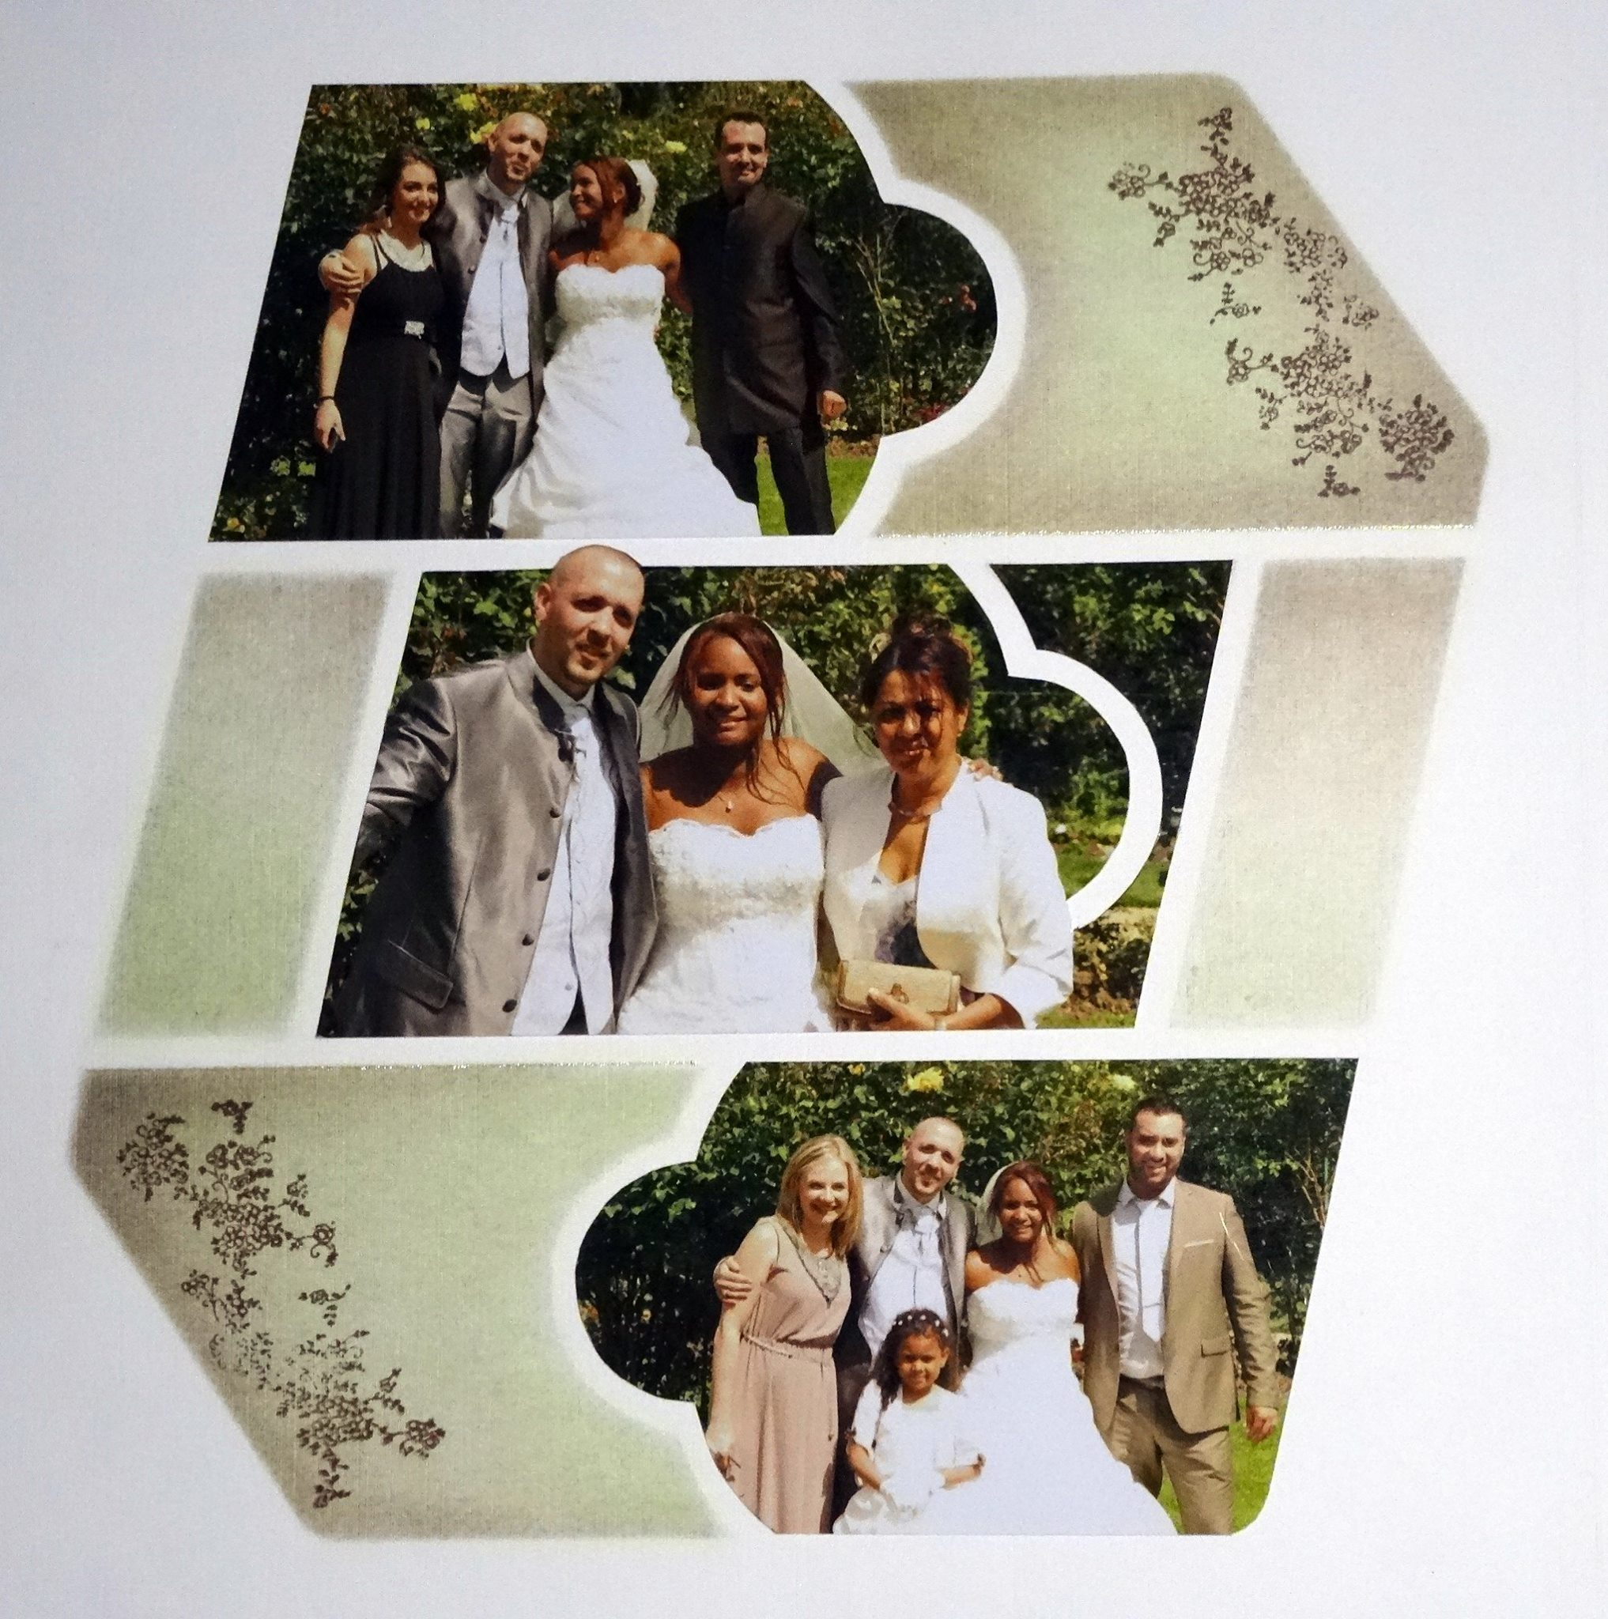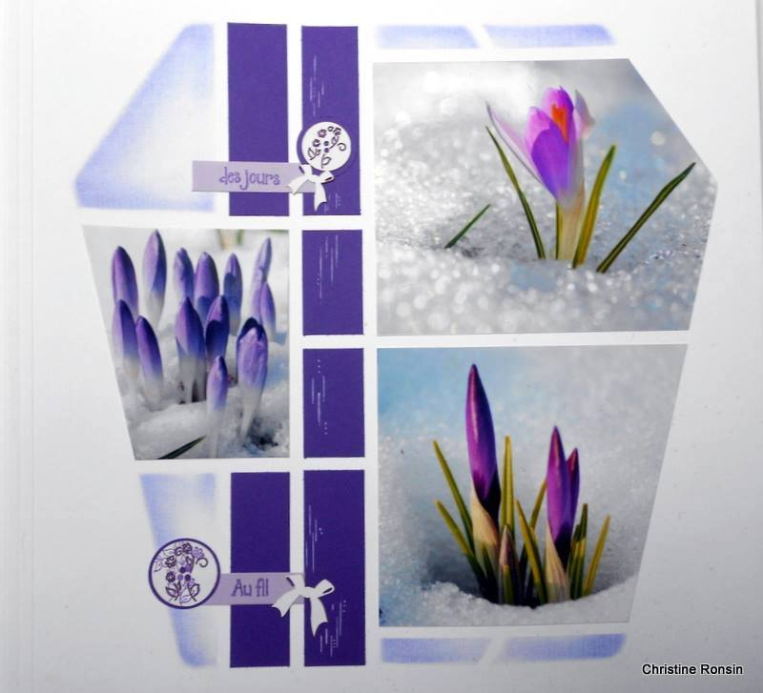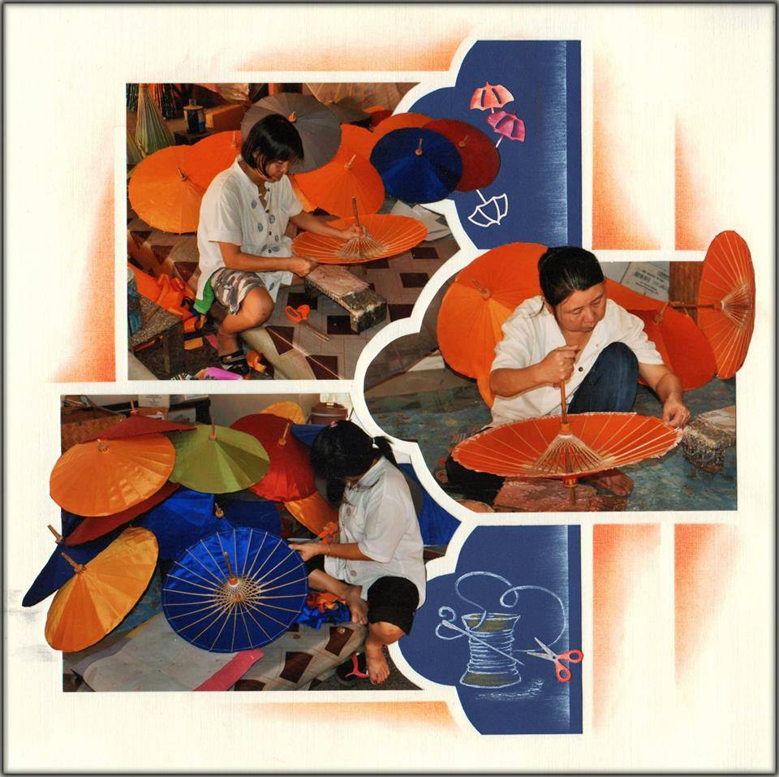

Sadly, my classes in Rydalmere have come to an end. Alice is now in a smaller shop and there is only one area for classes. I am looking to find another room where we can hold classes. One of my regular Clients whom many of you will know has offered to have a Saturday morning class in her home. She lives off Parsonage Road, Castle Hill. I will put the dates up on the Blog but the first class will be on Saturday 28th February. Call me if you would like to come along, once you have booked I will give you the full address.

Classes in Turramurra begin tomorrow. I am working on the third Wednesday of the month, once again classes will be posted on my blog. If you have not found my blog yet, search for “lyn holmes” and you will find ‘Let’s create with Lyn Holmes’. You can enter you e-mail address there and anything I post will land in your in-box as I upload it. I also have a Face book page and a Pinterest page where I post lovely samples I find in cyberspace.

Remember you can always hold a class in your home with 5 or more Ladies and I will be happy to come along with all the AZZA product for you to use.

Don’t forget some of the older templates:

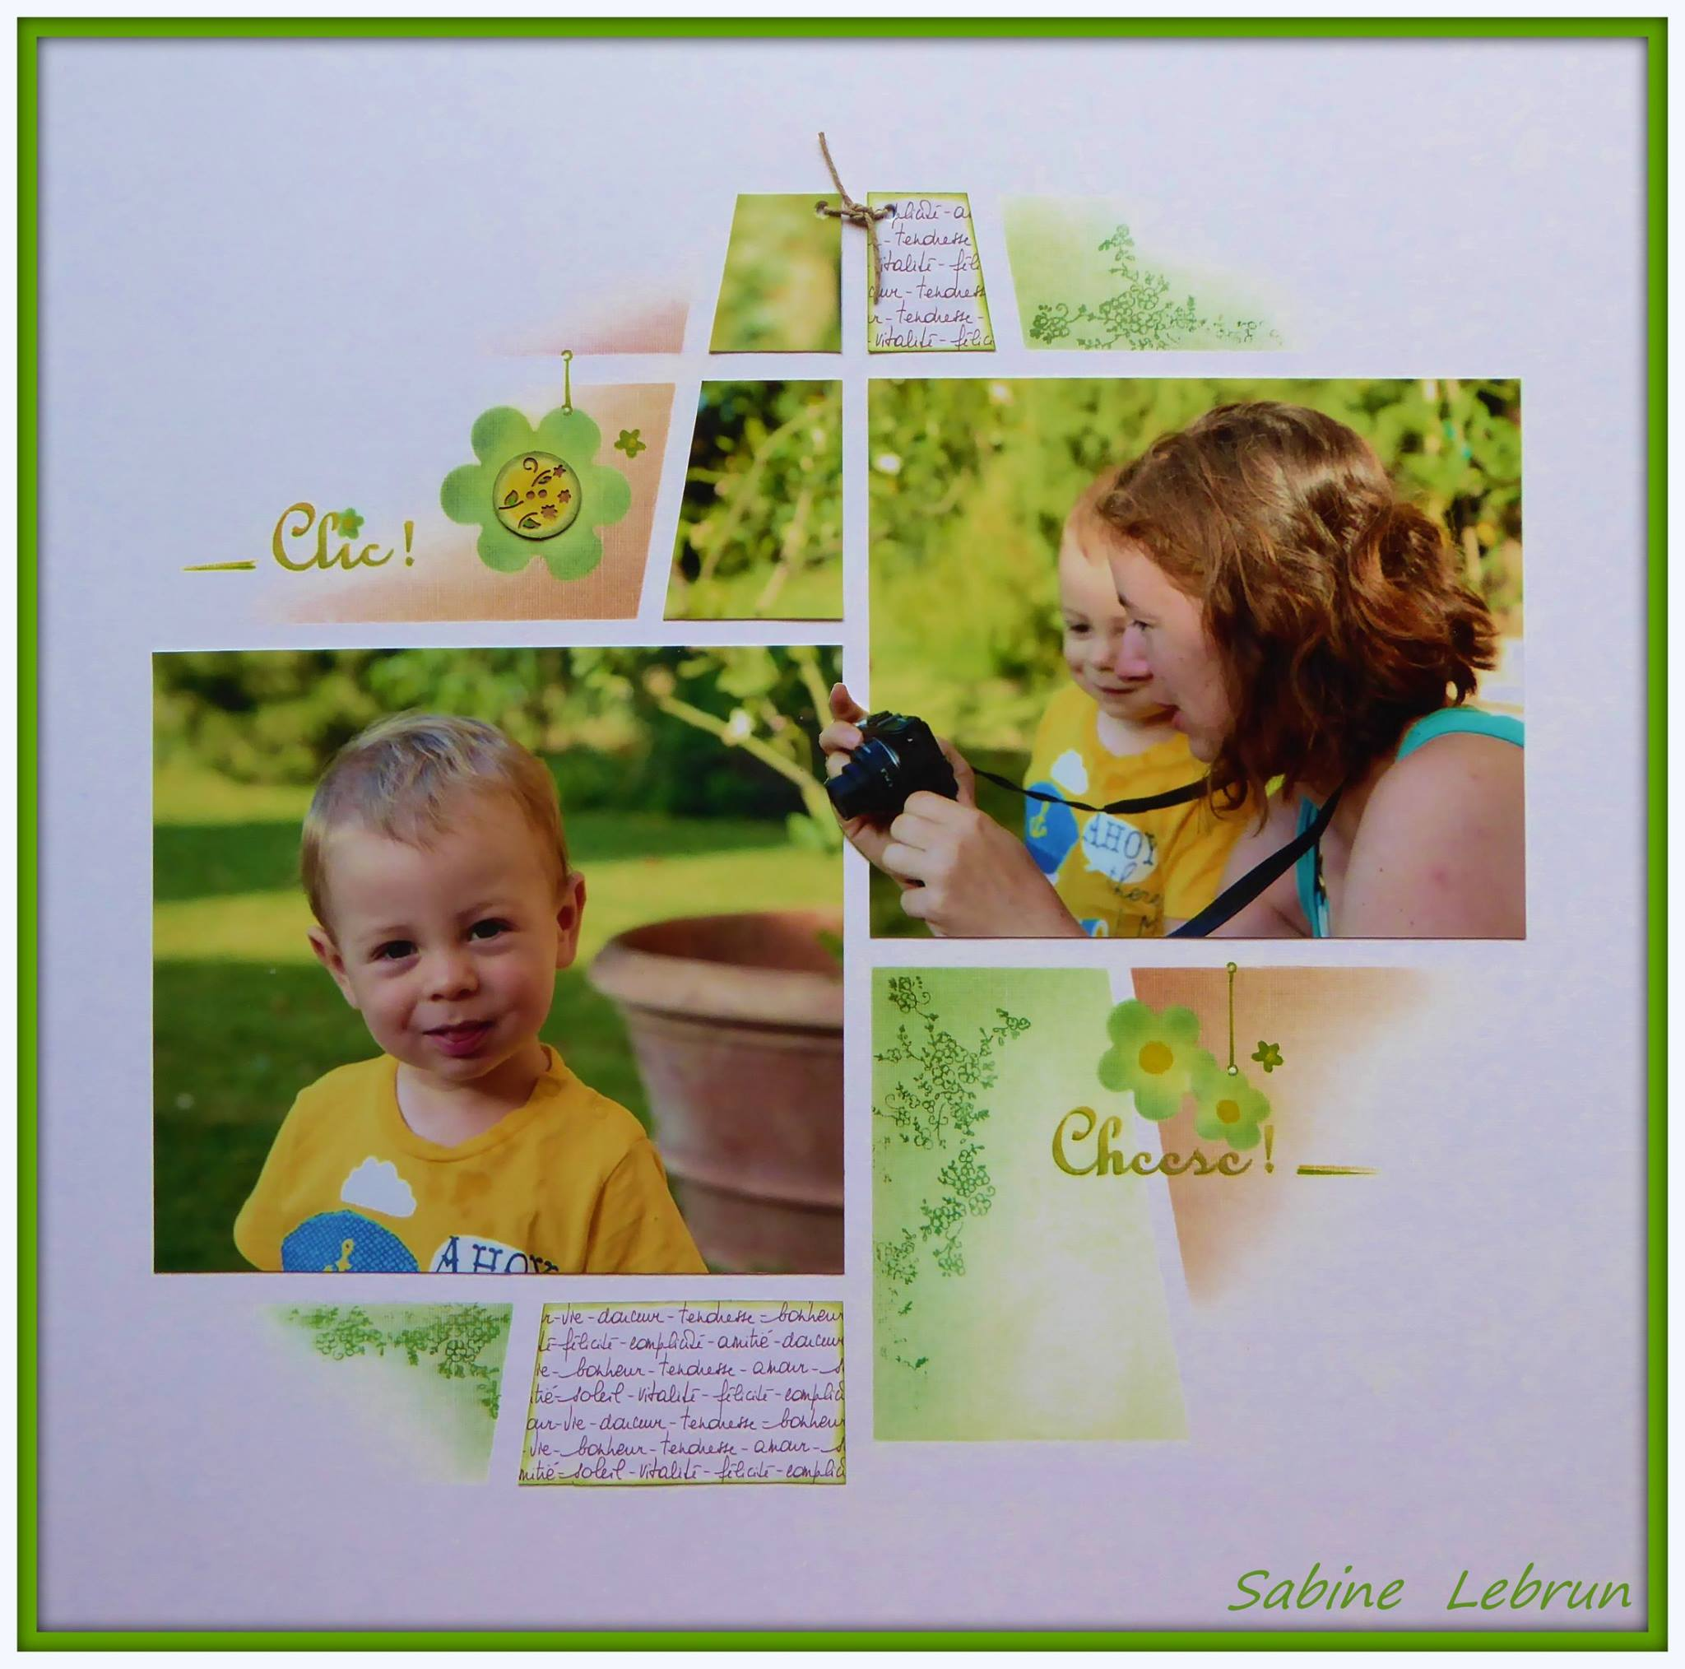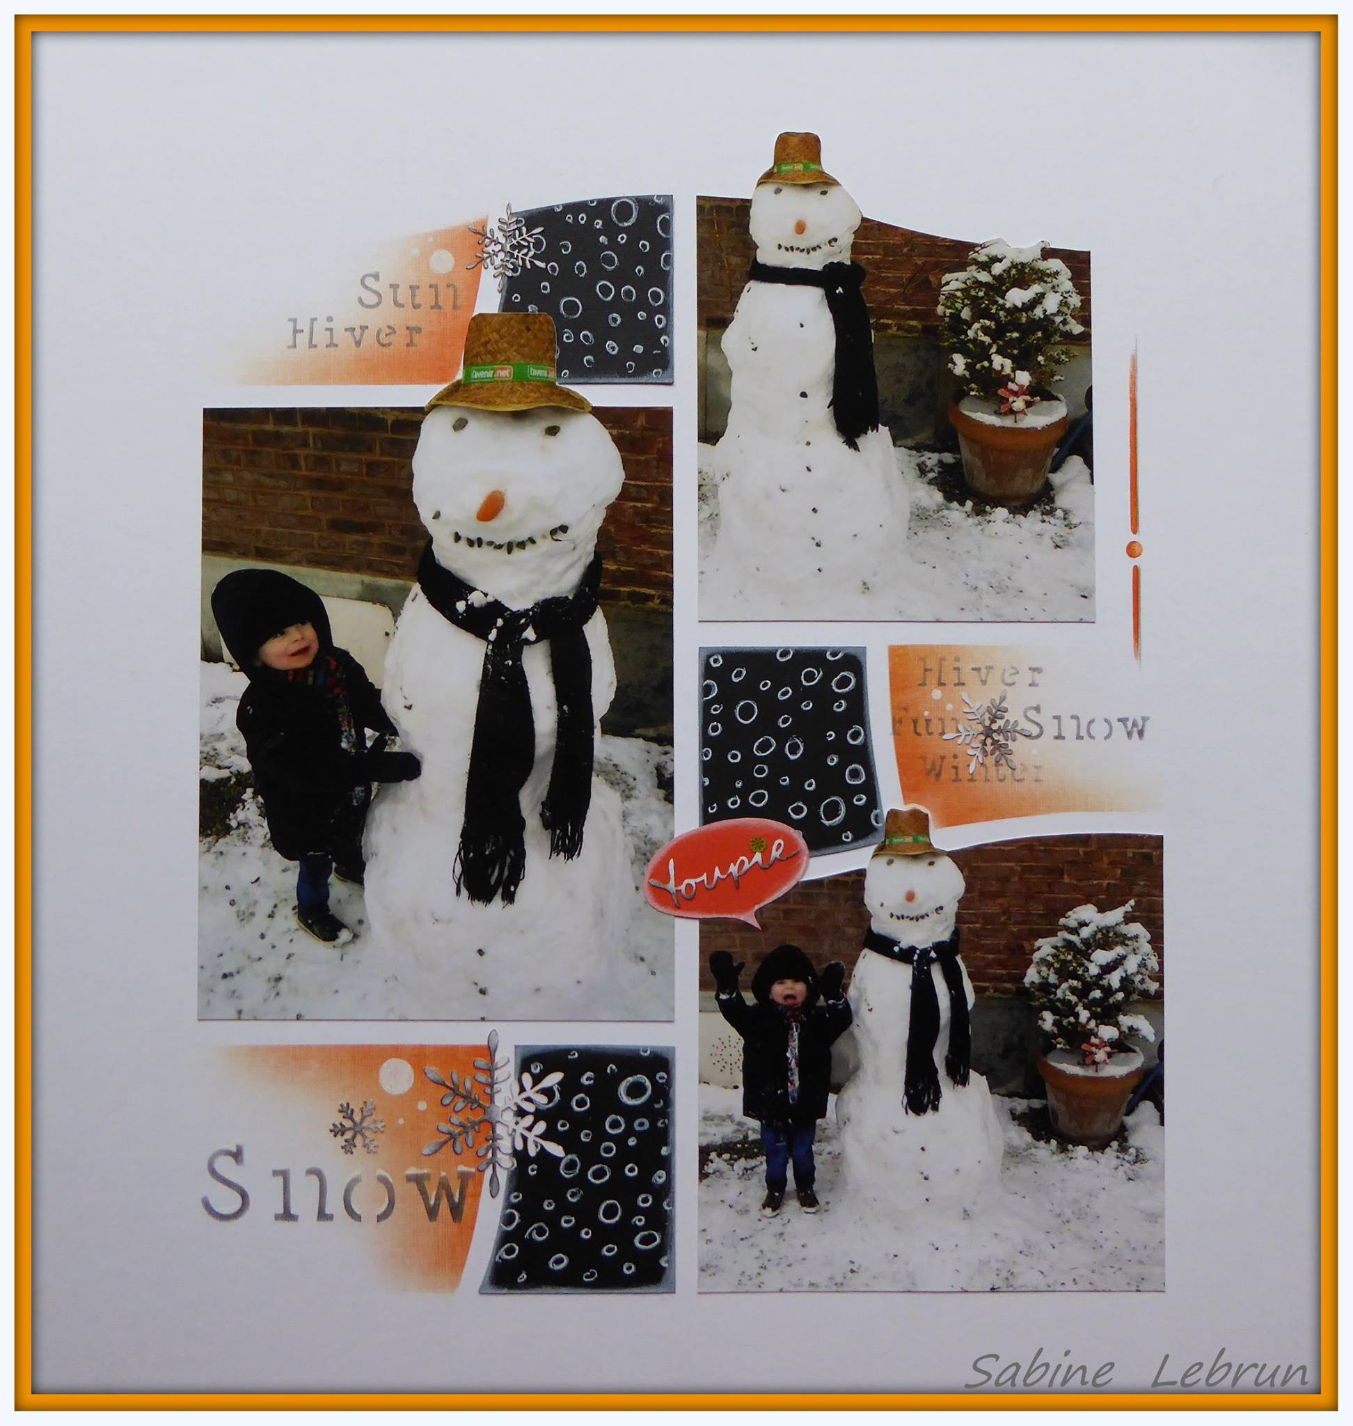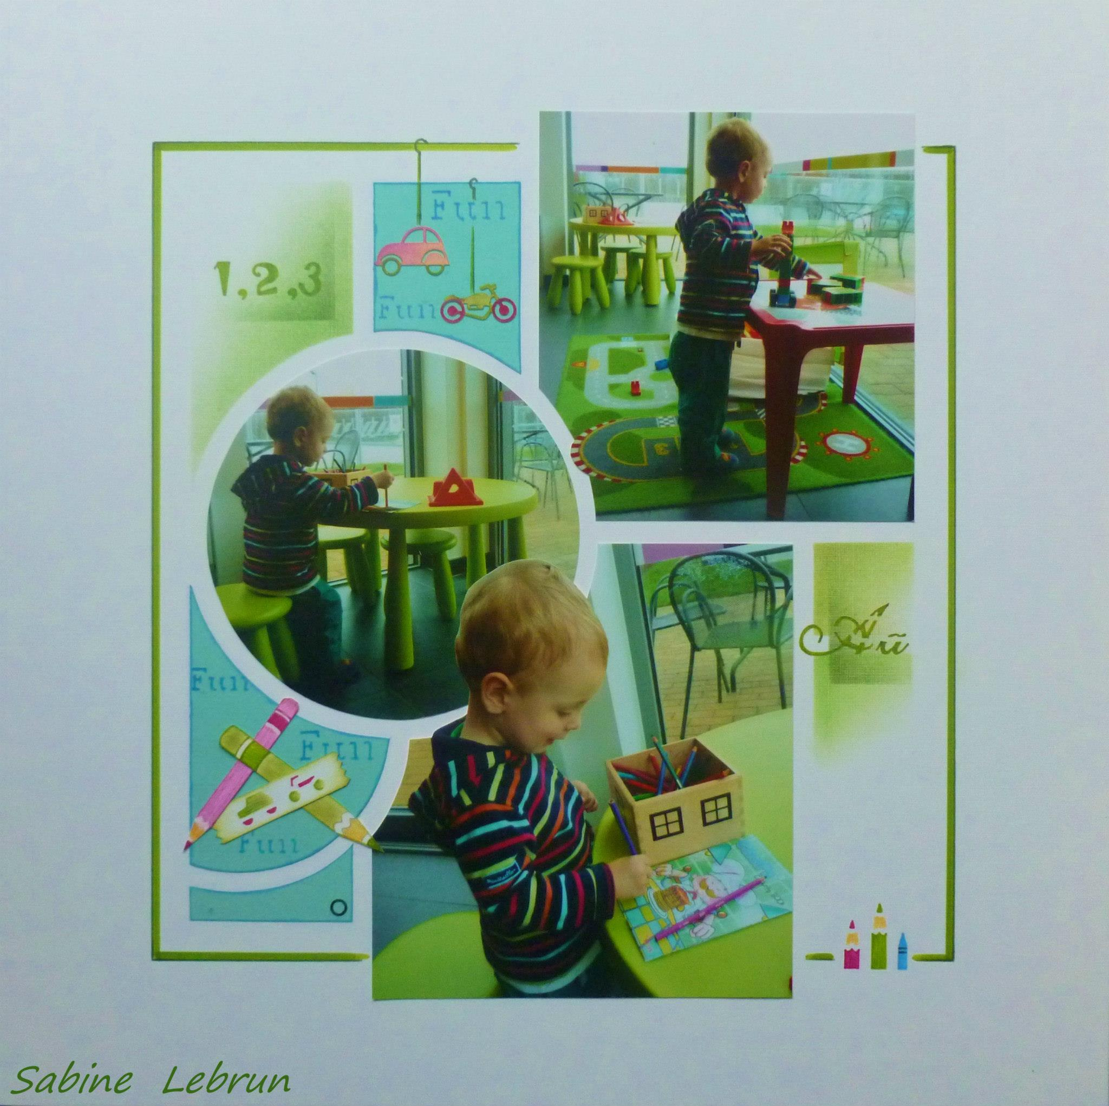

Herewith a few pages by Sabine Lebrun, her pages are beautiful.

Well I hope this gives you some inspiration to get scrapping again. If you would like a Focus Class on Chalking, Inking, Stamping ….. or anything else (that I am able to do!) please let me know and we can work it into the schedule.

Remember all our products can be seen in our online catalogue at AZZAworld.com.au. You can order online but there is a flat rate of $20.00 postage so it is much cheaper to order through a Consultant and pay the specific postage from Brisbane to your home, or you can collect from me.

AZZA is always looking for new Consultants – if you are interested in becoming a Consultant please get in touch.

Best Wishes for 2015
Regards
Lyn
February, 2015

